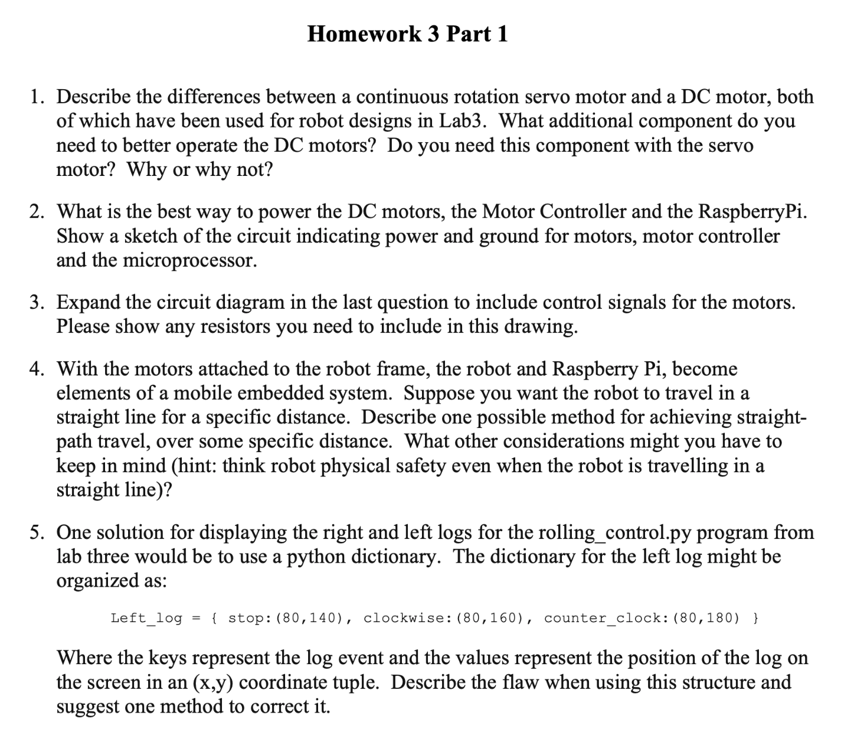

1. A continuous rotation servo motor has 3-wire system: power, ground, and control. A servo also already has the required drive electronics. As a result, we can directly control the servo motor by passing PWM signals. On the other hand, DC motors is a 2-wire system: power and ground. It does not have the required drive electronic. For DC motors that we are going to use in Lab3, we would need a motor controller/driver. This driver will act as an interface between the RPi and the motor. It will take in PWM signals from RPi to control the motor and will take in the required power from another power source (the battery) to power the motor. We do not need a motor controller for servo motors because it already has the drive electronics in it, and can perform the required controls based on the PWM input.

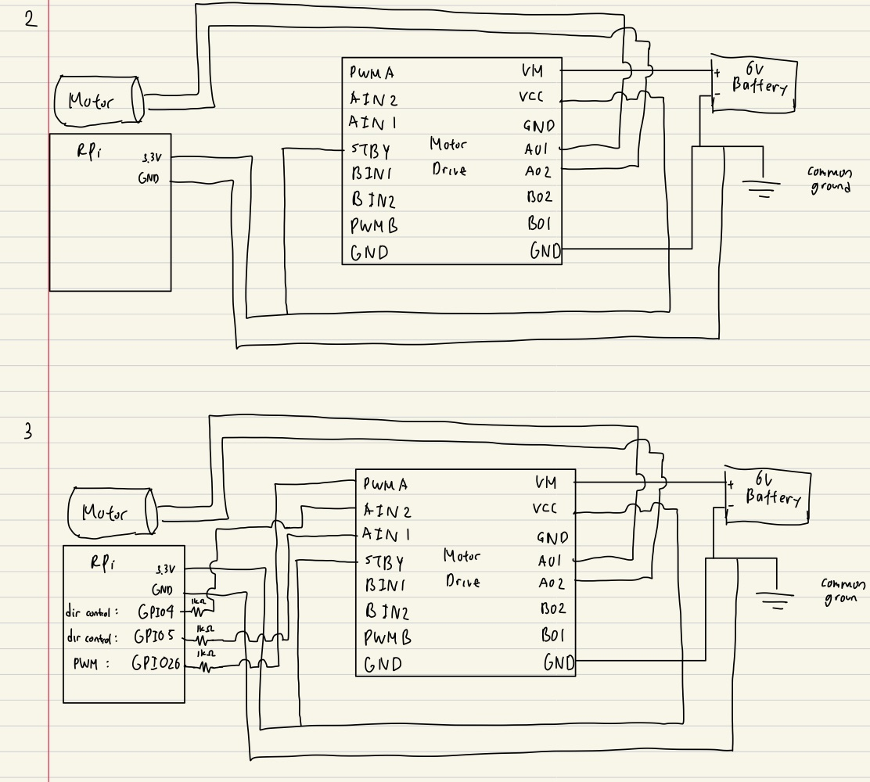

4. In order for the robot to travel in a straight line, the initial thinking is to just supply the four wheels on both sides with the same amount of power to travel at the same speed. A simple method to achieve a specific distance is to measure the time it takes our motor to complete one cycle at a set duty cycle. We can then measure the circumference of the wheel and calculate the distance traveled per rotation of the motor. Divide desired distance by this amount to get the number of rotations needed and multiply by time per rotation. We can then set our motor to run at this set duty cycle for this specific amount of time. However, in reality different terrains may cause wheels to suffer slips and the robot will not travel in a straight line. One method is to use an ultrasonic sensor and a gyroscope. One ultrasonic sensor will be attached to the front of the robot to make sure that the robot did not crash.The gyroscope will be used to make sure that the robot is traveling straight to a single direction, and will adjust the wheels to turn to maintain a straight line.

5. The problem is that the dictionary structure does not keep order or sequence. On the other hand, we would want to keep the order in a log, so a dictionary is not suitable. We can instead use a queue or a list structure, as they will keep the order or sequence. This allows us to keep a good log of the latest executed actions of the robot.